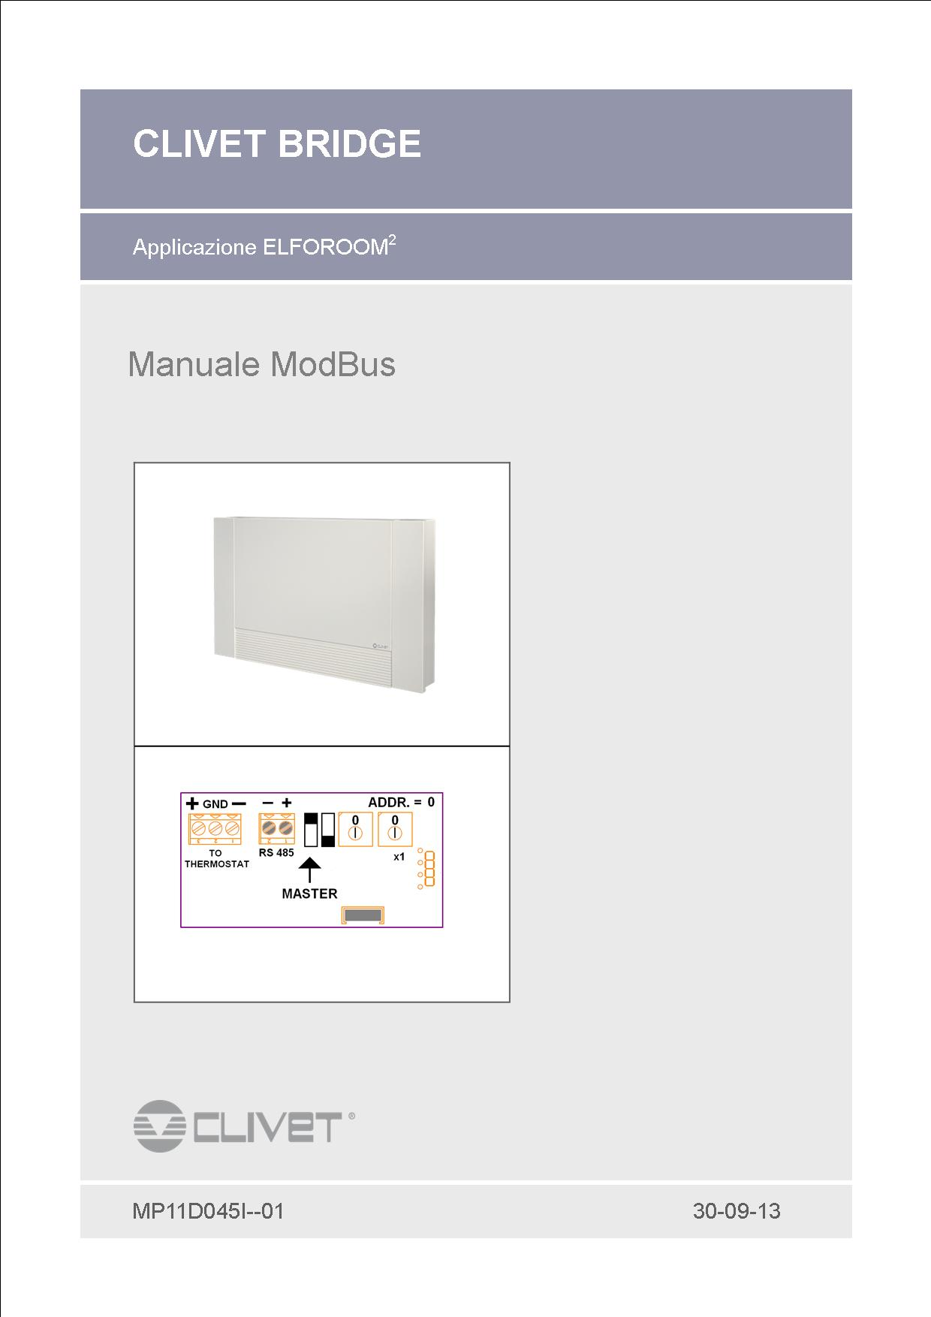

*Dear Customer,*

*We congratulate you on choosing this product*

*Clivet has been working for years to offer the market systems capable of ensuring maximum well-being for a long time with high reliability, efficiency, quality and safety.   
The company's goal is to provide its customers with advanced systems that ensure the best comfort, reduce energy consumption, installation and maintenance costs for the entire life cycle of the system.*

*With this manual, we wish to provide information that may be useful in all phases: from receipt, to installation, to use and up to disposal, so that such an advanced system meets the best installation and use methods.*

*Best regards and happy reading.*

*CLIVET Spa*

The data contained in this manual are not binding and can be changed by the manufacturer without notice. Reproduction, even partial, PROHIBITED

**INDEX**

1  Bridge layouts  4

2  Plant configuration  5

3  Modbus  8

3.1  Software version  8

3.2  Parameters  8

3.3  States common to Room, Space and zone module  9

3.4  Supervisor-related variables: Starting address 2100.  **Feil! Bokmerke er ikke definert.**

3.5  Flag register: Local settings register (Room, Space and MZ)  10

3.6  Common current and local mode mapping  10

3.7  Common Remote mode mapping  10

3.8  Digital input mapping  11

3.9  Relay mapping  11

3.10 Room  11 alarm mapping

**Bridge for Room2**

The project was born to make the fan coil "transparent" in Elfo system applications.

To do this, a "bridge" was developed on which there are two serial ports, a Modbus used for supervision and for the master-slave network and a Clivebus where to connect the Hid-T2 or Hid-T3 thermostat.

# Bridge layouts

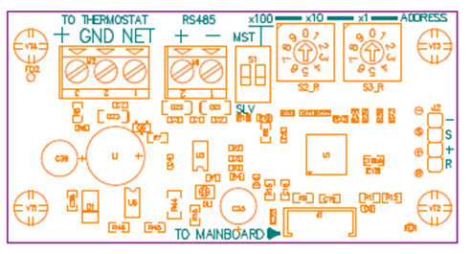

“TO THERMOSTAT”: Clivet Bus serial

“RS485”: Modbus slave serial for supervision and Modbus master\slave for the master-slave mininetwork, (the serial configuration takes place either with the MST/SLV dip or with parameter P40)

“ADDRESS”: Modbus Hw addressing, when set to zero, the Sw addressing (Parameter P32) takes on meaning

“TO MAINBOARD”: Connection serial with the base of the fancoil

# Plant configuration

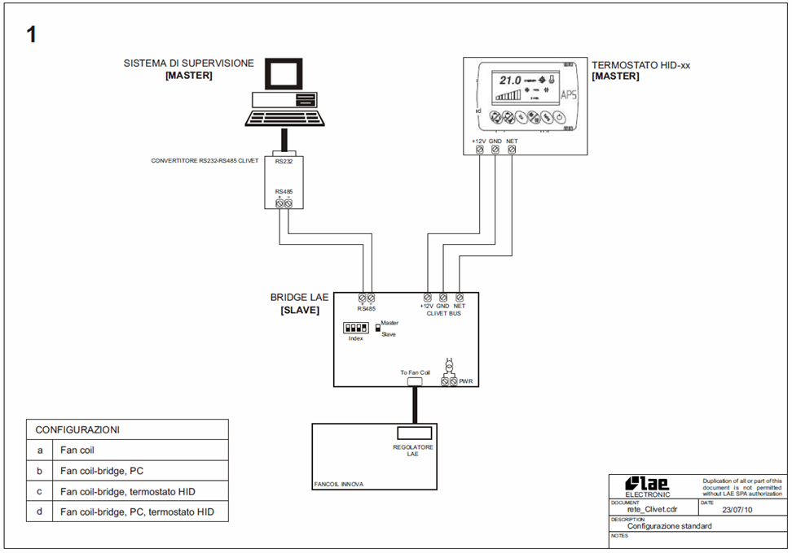

Remarks: Refer to the file "reteClivet_230710.pdf",

Attention, the bridge is powered directly by the base.

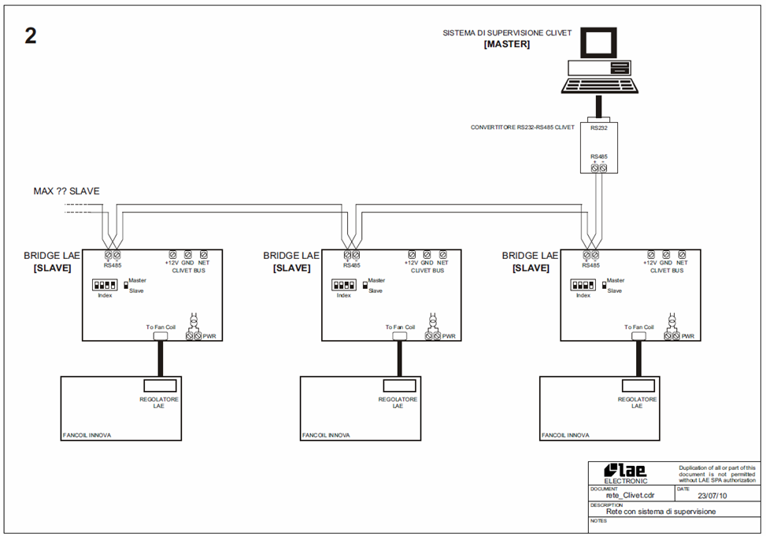

Remarks: Refer to the file "reteClivet_230710.pdf",

Attention, the bridge is powered directly by the base.

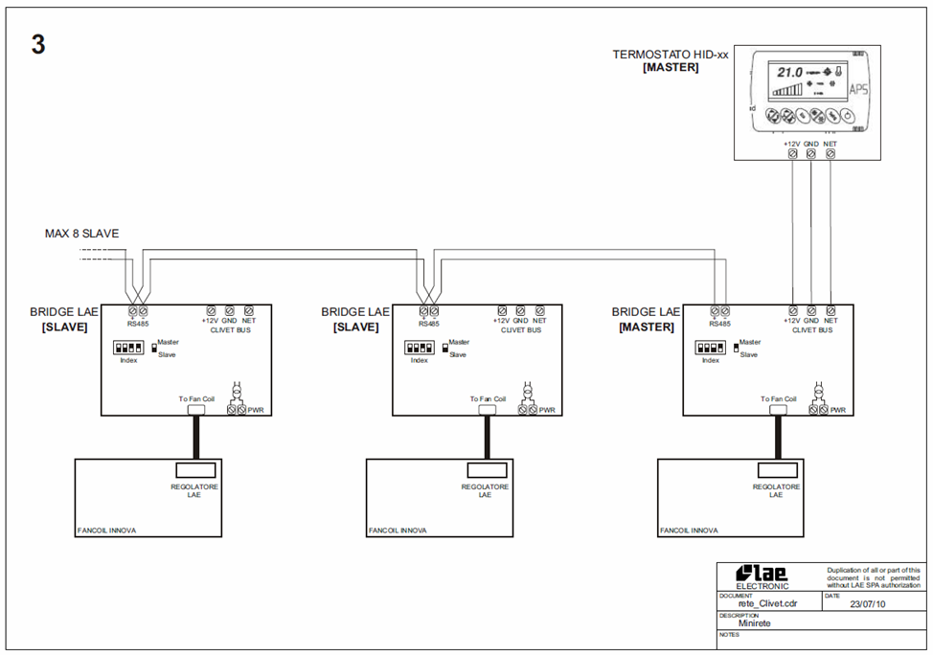

Remarks: Refer to the file "reteClivet_230710.pdf",

Attention, the bridge is powered directly by the base.

# 

# Modbus

## Software version

**Administrerte kommandoer: lese 3 og 4; Write 6 og 16.**

start address : 1; det er obligatorisk å lese 4 ord samtidig som har følgende betydninger:

|  |  |  |  |  |
| --- | --- | --- | --- | --- |
| **Modbus address** | **Byte** | **Description** | **Read** | **Write** |
| 1 |  | Mask Firmware | x |  |
| 2 |  | Rev | x |  |
| 3 | MSB extension | Rev E2 | x |  |
|  | LSB | Dag | x |  |
| 4 | MSB extension | Maned | x |  |
|  | LSB | År | x |  |

## Parameters

| **Modbus address** | **Par** | **Description** | **range** | **UM** | **default** | **Note** |
| --- | --- | --- | --- | --- | --- | --- |
| 1000 | P01 | **Arbeide bandet: Arbeide bandet** | 0 ÷15.0 | °C | 2.0 |  |
| 1001 | P02 | **MaxH2Ocool:**  Maksimumstemperatur for vann i kjøledrift | 0 ÷30.0 | °C | 20.0 |  |
| 1002 | P03 | **MinH2OHeat:**  Minimumstemperatur for vann i varmedrift | 0 ÷40.0 | °C | 30.0 |  |
|  |  |  |  |  |  |  |
| 1008 | P09 | **MaxRange** | 0…10.0 | °C | 2.0 |  |
| 1009 | P10 | **OffsetEco** | 0 ÷4.0 | °C | 3.0 |  |
|  |  |  |  |  |  |  |
| 1013 | P14 | **Priority** | 0 - 1 | no | 1 | 0=Probe luft inn  1=Probe thermostat |
|  |  |  |  |  |  |  |
| 1015 | P16 | **FanSpeedMin**  minimumsverdien av styresignalet | 0..100 | % | 30 |  |
| 1016 | P17 | **FanSpeedMax**  maximumsverdien av styresignalet | 0…100 | % | 65 |  |
|  |  |  |  |  |  |  |
| 1018 | P19 | **FanSilentMax** | P16…P17 | % | 45 | Quiet place |
|  |  |  |  |  |  |  |
| 1027 | P28 | **Lokal tvangkjørings tid (On/Off)** | 0…12 | Time | 6 |  |
| 1028 | P29 | **System type** | 0…1 | no | Read only | 0: 2 rør  1: 4 rør |
|  |  |  |  |  |  |  |
| 1030 | P31 | **ModeAuto:**  Activate auto mode | 0…1 | no | 0 | 0: Manual  1: Car |
| 1031 | P32 | **FanAuto:**  Aktivere auto viftehastighet | 0…1 | no | 0 | 0: Manual  1: Car |
| 1032 | P32 | **Address** | 0,..127 | no | 15 |  |
| 1033 | P34 | **Baud Rate** 0=4800 1 :9600 2:19200 | 0 … 1 | flags | 1 |  |
| 1034 | P35 | **Paritet** (0=nei, 1=Ulike, 2=Like) | 0 …1 | flags | 0 |  |
|  |  |  |  |  |  |  |
| 1036 | P37 | **Number zones** | 0….999 | no | 0 |  |
|  |  |  |  |  |  |  |
| 1039 | P40 | **Master:** Aktivering av master i mini nettverk | 0…1 | no | 0 | 0: Slaves  1: Masters |
| 1047 | P48 | **Lokal tvangkjørings setpunkt** | 0…12 | Hours | 0 |  |
| 1068 | P69 | ***Time Out nettverk:*** Timeout for seriell kommunikasjon (Modbus) | 1…600 | Sec | 60 |  |
| 1095 | P96 | ***Type thermostat*** | 0….1 | Flags | 0 | 1=Hid-Ti2 |

Observation:

Parameter P16 limited ()

Parameter P17 limited ()

Parameter P19 limited ()

Parameter P29 in read only (machine characteristic)

## States common to Room, Space and zone module

startadressen i 2300 (skrivebeskyttet ).

Området skal gjenskape noen lokale nettverk variabler representert i de områdene 2000 og 2100, 2200.

|  |  |  |  |  |  |  |  |
| --- | --- | --- | --- | --- | --- | --- | --- |
| ***Modbus offset*** | ***Par*** | ***First name*** | **beskrivelse** | **UM** | **range** | **Note** | **password.** |
| ***2300*** | ***S01*** | ***operational TEST*** | Ekstern tempføler | °C/10 |  |  | NO |
| ***2301*** | ***S02*** | ***TH2O operational*** | Vanntemperatur føler | °C/10 |  |  | NO |
| ***2302*** | ***S03*** | ***operational TARIA*** | Lufttemperatur føler | °C/10 |  |  | NO |
| ***2303*** | ***S04*** | ***Operational UR*** | Luftfuktighet føler | HR% |  |  | NO |
| ***2304*** | ***S05*** | ***Modes*** |  |  | bitmaps |  | NO |
| ***2305*** | ***S06*** | ***Innstilt set point*** |  | °C/10 |  |  | NO |
| ***2306*** | ***S07*** | ***Innstilt luftfuktighet*** |  | HR% |  |  | NO |
| ***2307*** | ***S08*** | ***alarm*** |  |  | bitmaps |  | NO |
| ***2308*** | ***S09*** | ***Befuktning aktiv*** | No zone module | Flags |  |  | NO |
| ***2309*** | ***S10*** | ***Avfukting active*** |  | Flags |  |  | NO |
| ***2310*** | ***S11*** | ***Life status*** | 0: av  1: på | Flags | 0…1 |  | NO |
| ***2311*** | ***S12*** | ***Vifte type*** | 0-7 motor 0-10V  0-3 motor 3 hastigheter  0-1 motor 1 hastighet | number | 0…7 |  | NO |
| ***2312*** | ***S13*** |  |  |  | bitmaps |  | NO |
| ***2313*** | ***S14*** | ***Relay Status*** |  |  | bitmaps |  | NO |

TEST operating external temperature on which thermoregulation takes place (local or remote)

TH2Ooperating water temperature on which thermoregulation takes place (local or remote)

TARIAoperating air temperature on which thermoregulation takes place (local or remote)

URoperating humidity on which thermoregulation takes place (local or remote)

## Variabler knyttet til supervisor : adresse 2100.

|  |  |  |  |  |  |
| --- | --- | --- | --- | --- | --- |
| **Modbus address** | **Byte** | **Description** | **Read** | **Write** | **Unit** |
| 2100 |  | Fjernstyrt mode – b0-on/off, b1-Varme/Kjøling, b2-?, b3-ECO, b4-Silent, b5-Auto veksling mellom varme/kjøling, | x | x | Room-Space |
| 2101 |  |  | x | x |  |
| 2102 |  |  | x | x | MZ-Space |
| 2103 |  | DeumiOn | x | x | Room-Space |
| 2104 |  | Fjernstyrt set varme | x | x | Room-Space |
| 2105 |  | Fjernstyrt set kjøling | x | x | Room-Space |
| 2106 |  | Air temperature | x | x | Room-Space |
| 2107 |  |  | x | x | Room-Space |
| 2108 |  |  | x | x | space |
| 2109 |  | Register Flag | x | x | Room-Space |
| 2110 |  | Vifte nettverk | x | x | Room-Space |
| 2111 |  | Analog ON-OFF 1 | x | x | Room |
| 2112 |  | Analog ON-OFF 2 | x | x | Room |
|  |  |  |  |  |  |
| 2118 |  | Work grense | x | x | Room |

Notes: The set heat variation range is 10-25°C

The range of variation of the coll set is 15-35°C

## Flag register: Local settings register (Room, Space and MZ) Register 2109?

|  |  |  |  |  |  |
| --- | --- | --- | --- | --- | --- |
| **Modbus offset** |  |  |  |  |  |
| **Bit** | **First name** | **Description** | **default** | **Unit type** | **Note** |
| 0.1 | ***Setpoint*** | 0: Local  1: net med overstyling  2: net user overstyling | 0 | Room  space  MZ extension | Hvis aktivert kan setpunkt varieres innenfor visse grenser |
| 2.3 | ***modus*** | 0: Local  1: net med overstyring 4 rørs  2: net user overstyring 2rørs | 0 | Room  space  MZ extension | Hvis aktivert kan ikke mode forandres lokalt |
|  |  |  |  |  |  |
| 5.6 | ***Status*** | 0: Local  1: net med overstyling  2: net user overstyling | 0 | Room  space  MZ extension | Hvis aktivert kan ikke skrues av lokalt |
| 7.8 | ***Viftestyring*** | 0: Local  1: net med overstyling  2: net user overstyling | 0 | Room  space | Hvis aktivert kan ikke viftehastighet forandres lokalt |
|  |  |  |  |  |  |
| 10 | ***Temperature probe*** | 0: Local  1: Nett | 0 | Room  space  MZ extension | 0: at avlesningen gjøres på enheten (termostat eller probe).  1: hvis det ikke er nettverk gjelder den lokale termostat lesing eller probe. |
| 11 | ***Tastelas*** | 0=Lokal (kan ikke overstyres av nett)  1=Nett (kan ikke overstyres an local) | 0 | Room |  |
| 12 | ***Thermostat blocking*** | 0=Lokal (kan ikke overstyres av nett)  1=Nett (kan ikke overstyres an local) | 0 | Room  space  MZ extension |  |
|  |  |  |  |  |  |
|  |  |  |  |  |  |
| 15 | ***Tvinge timer reset*** | Skriv 1 for å resette 2 overstyrings timer | 0 | Room  space  MZ extension | NB: verdien på denne biten er alltid 0 |

## Common current and local mode mapping

|  |  |  |  |  |  |  |  |  |
| --- | --- | --- | --- | --- | --- | --- | --- | --- |
| **MSbits** |  |  |  |  |  |  | **LSbit** | ***unit*** |
| Call | AUTOFAN | Car | Silent | Echo | Cumulative alarms | Heat/Cool | ON/OFF | *Room* |
|  |  |  |  |  |  | Heat=1 | On=1 |  |

## Common Remote mode mapping

|  |  |  |  |  |  |  |  |  |
| --- | --- | --- | --- | --- | --- | --- | --- | --- |
| **MSbits** |  |  |  |  |  |  | **LSbit** | ***unit*** |
| Call | AUTOFAN | Car | Silent | Echo | Alarm reset | Heat/Cool | ON/OFF | *Room* |
|  |  |  |  |  |  | Heat=1 | On=1 |  |

*Auto: I command the automatic mode change

*AUTOFAN: Controls the automatic ventilation mode

Note: the alarm reset can also be done from the Hid-Tx thermostat by holding down the "Swing" button for more than 5 seconds

## Digital input mapping

No inputs mapped

## Relay mapping

|  |  |  |  |  |  |  |  |  |
| --- | --- | --- | --- | --- | --- | --- | --- | --- |
| **MSbits** |  |  |  |  |  |  | **LSbit** | ***unit*** |
|  |  |  |  |  |  | RL2 | RL1 | *Room* |

## Room alarm mapping

|  |  |  |  |  |  |  |  |  |
| --- | --- | --- | --- | --- | --- | --- | --- | --- |
| **MSbits** |  |  |  |  |  |  | **LSbit** | ***Byte*** |
| Mot |  |  |  |  |  |  |  | *High* |
|  |  |  | Filters | BT2 | BT1 | H2O | SYS | *Bass* |

Remarks:

EHH alarm : the Hid-Tx thermostat does not communicate with the bridge

SYS alarm: the Bridge does not communicate with the base

Mot alarm: fan motor sensor in alarm



**www.clivet.com**

The data contained in this manual is not binding and may be changed by the manufacturer without prior notice. All reproduction, even partial, is prohibited. © Copyright - CLIVET S.p.A. - Feltre (BL) - Italy

**CLIVET SPA**

Via Camp Lonc 25, Z.I. Villapaiera - 32032 Feltre (BL) - Italy

Tel. + 39 0439 3131 - Fax + 39 0439 313300 - info@clivet.it

**CLIVET UK LTD**

4 Kingdom Close, Segensworth East - Fareham, Hampshire - PO15 5TJ - United Kingdom

Tel. + 44 (0) 1489 572238 - Fax + 44 (0) 1489 573033 - info@clivet-uk.co.uk

**CLIVET SAS**

ZAC des Godets 1, Impasse de la Noisette, Hall A6 - 91370 Verrières le Buisson - France

Tel. + 33 (0)1 69202575 - Fax + 33 (0)1 69206076 -info.fr@clivet.com

**CLIVET ESPAÑA S.A.**

Parque Empresarial Villapark, Avda. Quitapesares 50 - 28670, Villaviciosa de Odón, Madrid - España

Tel. + 34 91 6658280 - Fax + 34 91 6657806 - info@clivet.es

**CLIVET GmbH**

Hummelsbütteler Steindamm 84, 22851 Norderstedt - Germany

Tel. + 49 (0) 40 32 59 57-0 - Fax + 49 (0) 40 32 59 57-194 - info.de@clivet.com

**CLIVET NEDERLAND B.V.**

Siliciumweg 20a, 3812 SX Amersfoort - Netherlands

Tel. + 31 (0) 33 7503420 - Fax + 31 (0) 33 7503424 - info@clivet.nl

**CLIVET RUSSIA**

Elektrozavodskaya st. 24, office 509 - 107023, Moscow, Russia

Tel. + 74956462009 - Fax + 74956462009 - info.ru@clivet.com

**CLIVET MIDEAST FZCO**

Rep Office: PO Box 28178 - Light industrial unit 10 -Dubai Silicon Oasis - Dubai, UAE

Tel. + 97 14 3208499 - Fax + 97 14 3208216 - info@clivet.ae

**Clivet Airconditioning Systems (P) Ltd**   
3C3, Gundecha Onclave,  
Kherani Road, Saki Naka, Andheri (East), Mumbai 400 072 (INDIA)

Tel. + 91 - 22 - 6193 7000 - Fax + 91 - 22 - 6193 7001 - sales.india@clivet.com 150311